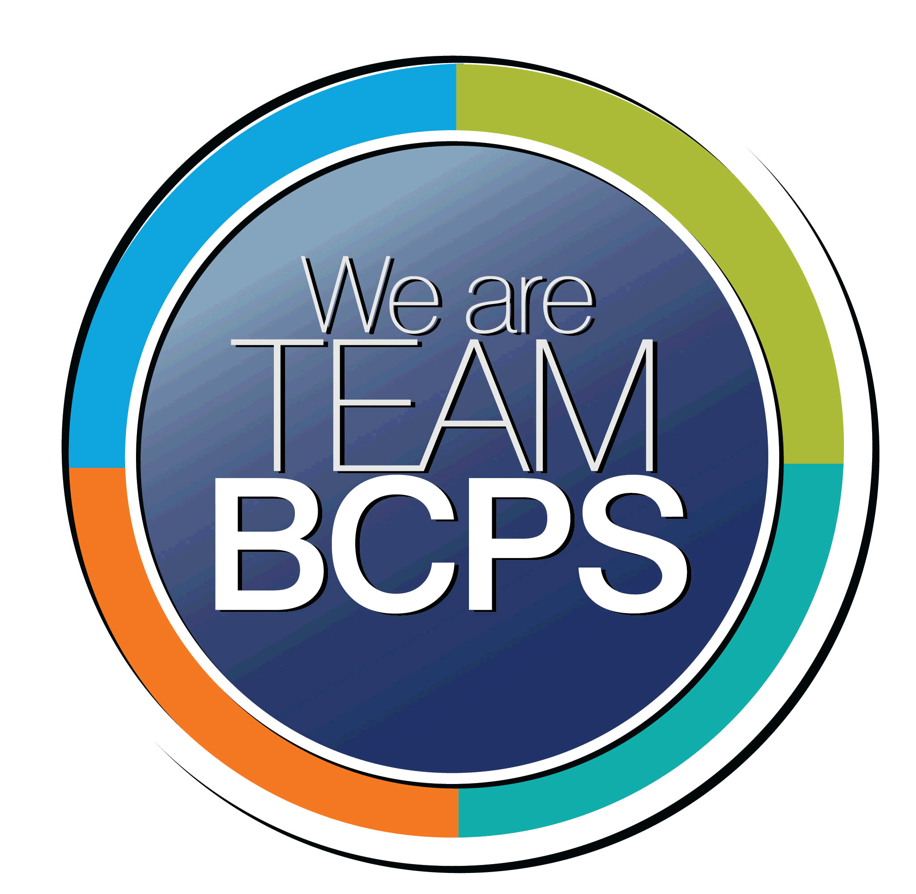 **Schoolwide Positive Behavior Plan** 

**Baltimore County Public Schools**

**Date Completed: 8/1/2022 School Year 2022-2023**

**School: Fullerton Elementary**

|  |
| --- |
| **Section 1: Initial Steps** |
|  |
| **School Climate Team** |
| *Identify members of a School Climate Team (consider a representative selection of members). The team meets initially to examine equity concerns and data and to develop the Schoolwide Positive Behavior Plan. The team should then meet monthly (minimum quarterly) to assess the effectiveness of the SWPBP on an ongoing basis.* |
| Candace Winterson- Salkowski – Principal  Vicki Waite- Assistant Principal  Lori Tagliaferro- Reading Specialist  Cathye Cossaboon- Guidance Counselor  Andrew Boyer- Classroom Teacher  Kelsey Matuszak- ESOL Teacher  Jennifer Childs-Special Education Teacher  Holly Gilmore-Classroom Teacher  Tara Jones- Music Teacher |
| **Equity Lens** |
| *Through an equity lens, identify what the data indicate about the social-emotional needs of students and the support provided by staff members relative to disproportionality between student groups, especially for African Americans or students receiving special education. Also consider the school’s population with regard to ELL, Latinx, and/or other student groups. (Information may be from School Data Story)* |
| Data analyzed during School Progress Planning |
| **Data Analysis** |
| *Summarize what the data tell about the school climate. (Information from School Data Story)* |
| Data analyzed during School Progress Planning |
| **Climate Goals** |
| *Identify the school’s goals in improving the social-emotional climate of the building. (Information from School Progress Plan)* |
| Culture- Key Action #1 Classroom routines and expectations promote cooperative learning, teacher to student interactions and student to student interactions characterized by mutual respect and caring.  Culture- Key Action #2 Teachers will create and sustain a safe, welcoming, and supportive classroom environment which values inclusivity and diversity.    . |
| **Section 2: Developing and Teaching Expectations** |
|  |
| **Expectations Defined** |
| *Identify a School Code of Conduct with 3-5 positively stated school expectations. Develop a way to communicate the identified rules, based on the schoolwide expectations, for specific settings within the school building. Expectations should be clearly stated, communicated, taught, and frequently referenced.* |
| I am a Fullerton student therefore:  I am ***responsible***, I am ***prepared***, I am ***respectful***, I am ***safe.***  We are here to learn therefore:  I will do nothing to prevent my teachers from teaching or anyone else from learning.  I will cooperate with my school family. I will respect myself, others and the environment. |
| **Classroom Plan for Teaching and Reinforcing Expectations, Routines, and Procedures** |
| *Teachers develop visuals to communicate culturally relevant classroom expectations, routines, and procedures based upon the schoolwide expectations. Educators explicitly teach expectations, routines, and procedures. The school staff recognize and reinforce expected and positive behavior. Teachers identify encouraging procedures and corrective procedures for their classrooms.* |
| * Teachers show and model the behavior- what it looks like/sounds like * All staff commit to teach, model, cue (remind students regularly), and reinforce positive behavior. * We recognize that all students need structure and clearly stated high expectations and to be engaged in learning. * We will provide correction, reminders and praise. * We define behavioral expectations and provide “the why” behind our expectations. * We will share new transportation and cell phone usage plans and expectations. |
| **Family/Community Engagement** |
| *Identify how the Schoolwide Positive Behavior Plan, the schoolwide expectations, and/or interventions will be communicated and shared with families. Consider how to include family and student voice in the initial plan and in evaluating the plan throughout the year.* |
| **Fullerton** engages families in the shared decision-making process by working with families as equal partners in the education of the students. This sharing and explaining occurs through a variety of formats including:   * Back-to-School Nights * Parent-teacher conferences * Virtual or face-to-face PTA meetings * Recorded video or phone messages * School Newsletters * Community newspapers and/or community-specific social media * American Education Week activities * School Surveys * Translations of documents and use of the Language Line * Meetings with students for student voice and feedback |
| **Section 3: Developing Interventions and Supporting Students** |
|  |
| **Resource Mapping of MTSS** |
| *Identify the evidence-based practices and interventions offered at Tier 1, Tier 2, and Tier 3 to support all students. Consider what culturally responsive interventions the school requires to meet the specific needs of the students.* |
| We use Multi-Tiered Systems of Support to meet the unique and diverse needs of each student at Fullerton.  **Tier 1:**   * Clear Behavioral Expectations in all settings * School wide Matrix * Teaching, Modeling and Reinforcing Behaviors * Positive Reinforcements * Community Meetings * SEL- Three Signature Practices * Proactive Classroom Management Strategies * Restorative Practices: Talking Circles, Affective Questions, Restorative Conferences * Logical Consequences   **Tier 2 and 3:**   * Tier 2 and 3 Supports, which may include: * Check in Check Out * Behavioral Contracts and Behavioral Plans Counseling support * Social Groups, Social Stories, Picture Cues Coaching, Modeling, Pre-Teaching * Mentoring * Academic Interventions * Behavior Charts/BIP |
| **Social-Emotional Learning** |
| *Identify the specific evidence-based social-emotional learning skill development practices the school will implement during the school year. Consider the importance of trauma-informed care, mental health awareness, level of students’ coping skills, etc. Determine how the social-emotional learning and the SEL competencies will be integrated into the school’s programming. Consider the need for any training the staff members may require.* |
| Building and sustaining relationships.  Working on Executive Functioning Skills  Adult Social Emotional Learning  Implement MTSS supports and Conscious Discipline strategies and rituals into daily practice  . |
| **Character Education** |
| *Determine how specific evidence-based character education learning will be infused into the school’s programming to promote positive behavior and ethical decision-making. Character education will be culturally responsive and co-created with diverse stakeholders. Consider the need for any training the staff members may require.* |
| **Click or tap here to enter text.** |
| **Professional Development for Staff** |
| *Identify the professional development that will be offered to staff members throughout the year in order to support their knowledge, skill development, and implementation of the interventions selected, the character education learning, and social-emotional learning practices. Specify the schedule for professional development and how to obtain teacher feedback during the year to address their concerns and areas in which they want/need more information. (Information from School Progress Plan.)* |
| BCPS Professional Development Coursework  Overview of the Schoolwide Positive Behavior Plan and SPP to the faculty during Teacher Preparation Week.   * + Teach the schoolwide expectations   + Understand the importance of documenting classroom managed behaviors (referrals)   + Know how to complete an office referral according to expectations   + Understand how to deliver Behavior Specific Praise and positive reinforcement   + Develop a hierarchy of classroom management procedures |
| **Section 4: Supporting and Responding to Student Behavior** |
|  |
| **Recognitions/Incentives** |
| *Identify a variety of positive consequences, acknowledgements, recognitions, and/or incentives that are linked to the behavioral expectations and rules. Develop a system for implementing the positive acknowledgements consistently in school settings. Consider how to monitor who is being recognized and who is not being recognized and whether explicit or implicit biases may be occurring.* |
| * Positive Reinforcement * Behavior Specific Praise * Using Evidence Based Classroom Management strategies * Positive phone calls/notes home * Positive Office Referrals * House Program |
| **Hierarchy for Behavioral Referrals and Consequences** |
| *Identify the behaviors that are teacher-managed, behaviors referred to resource staff, and behaviors referred to administration. Refer to the BCPS Student Handbook for teacher and administrator-led interventions. Consider how unsafe behaviors will be addressed.* |
| * We believe in being proactive vs. reactive when handling unexpected behavior. * Use of the BCPS Behavior Handbook for intervention strategies.   We define staff managed versus administrator managed behavioral support as: Anytime a student’s safety is at risk, we call on an administrator for support.   * Repetitive behavior that disrupts the school program can result in a behavior referral. Logical consequences are given using the BCPS Student Handbook. |
| **Response for Intensive Behaviors** |
| *Identify a hierarchy of responses to intensive behaviors (i.e., emergency/crisis management/threat assessment/unsafe behaviors) including interventions and supports. Indicate which school staff members will respond as well as procedures and training as needed.* |
| Use of de- escalation strategies  Crisis Training for identified staff  Threat Management Process and the Behavior Threat Assessment Team  Support from the SRO  Community Mental Health Partnerships  Functional Behavior Assessments and Behavior Intervention Plans |
| **Monitoring the Schoolwide Positive Behavior Plan/Data Analysis** |
| *Identify the data that will be collected and reviewed by the School Climate Team in order to identify behavior trends, patterns, action steps, and interventions using a problem-solving strategy. Consider having a uniform referral form for staff to complete to document referrals to administration. Consider how teachers should document classroom-managed concerns/behaviors/difficulties. (Information from School Progress Plan.)* |
| * The following data will be collected and reviewed by the School Climate Team in order to identify behavior trends, patterns, action steps, and interventions using a problem-solving strategy. – * Attendance Data – * Response Calls/Office Referrals * Suspension Data * Stakeholder Survey Data - School culture/climate perceptions from students, teachers, and families |
| **Section 5: Miscellaneous Content/Components** |
| The schoolwide behavior plan is intended to be used for both virtual and in-person instruction |